Chapter 15 Reproductive System Sample Questions
There are 30 total questions on this test. The four that are not listed come from the labeling diagrams.

Multiple Choice
Identify the choice that best completes the statement or answers the question.

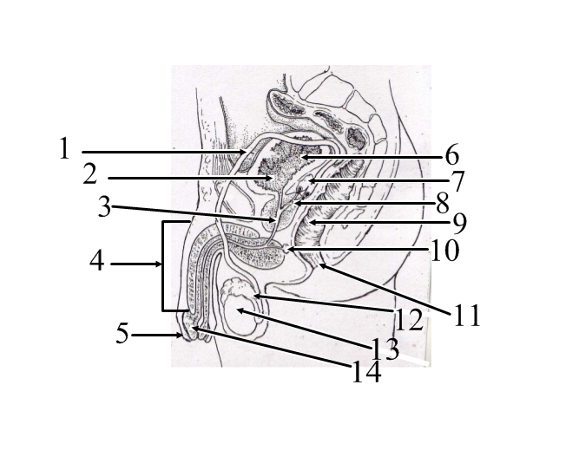Use the above diagram to answer the following questions:

1. Which structure stores immature sperm?
A. | 10
B. | 13
C. | 7
D. | 6
E. | 12

2. What is structure number 1?
A. | rectum
B. | uterus
C. | prostate
D. | bladder
E. | teste

3. The actual “sperm-forming factories” of the male reproductive system that empty sperm into the rete testes are called the:
A. | seminiferous tubules
B. | ductus deferens
C. | interstitial cells
D. | bulbourethral glands
E. | epididymis

4. What is structure number 10?
A. | ovary
B. | uterus: body
C. | uterus: fundus
D. | bladder
E. | teste

5. Each spermatid and ovum have:
A. | 2n chromosomes
B. | 23 chromosomes
C. | 46 chromosomes
D. | 23 pair of chromosomes
E. | 46 pair of chromosomes

6. The correct descending order of the male duct system (from inside to outside) is;
A. | ejaculatory duct, ductus deferens, epididymis, urethra
B. | ejaculatory duct, epididymis, vas deferens, urethra
C. | vas deferens, epididymis, ejaculatory duct, urethra
D. | epididymis, vas deferens, ejaculatory duct, urethra
E. | epididymis, vas deferens, urethra, ejaculatory duct

7. Which one of the following is NOT a component of semen:
A. | bulbourethral fluid
B. | prostatic fluid
C. | seminal fluid
D. | epididymal fluid
E. | sperm

8. A fertilized egg, which is the first cell of a new individual developing within the uterus is called a(n):
A. | embryo
B. | gamete
C. | zygote
D. | fetus
E. | gonad

9. Spermatogenesis begins:
A. | during puberty
B. | during adulthood
C. | at birth
D. | during old age
E. | prior to birth

10. The entire process of spermatogenesis takes approximately:
A. | 25-50 days
B. | 15 years
C. | 1 year
D. | 120 days
E. | 64-72 days

11. What is structure number 14?
A. | vagina
B. | urethra
C. | fallopian tube
D. | uterus
E. | vas deferens

12. The corpus luteum is a special glandular structure of the ovaries that primarily produces:
A. | testosterone
B. | interstitial cell-stimulating hormone
C. | luteinizing hormone
D. | progesterone
E. | estrogen

13. The seminal vesicles at the base of the bladder produce about ____% of the fluid volume of semen.
A. | 30
B. | 75
C. | 99
D. | 60
E. | 10

14. Fertiliztion usually occurs in the:
A. | uterine (fallopian) tubes
B. | ovary
C. | Graafian follicle
D. | uterus
E. | vagina

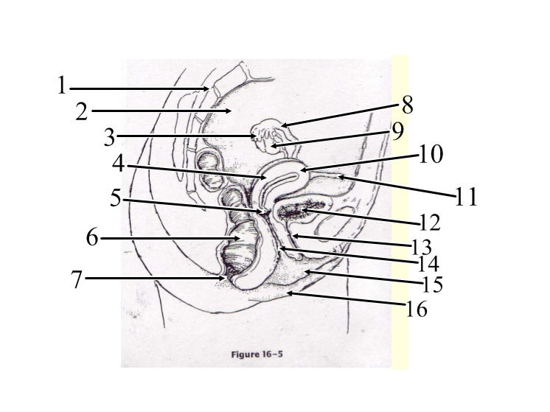Use the above diagram to answer the following questions:

15. Which of the following structures is not being pointed to in the diagram?
A. | urethra
B. | fallopian tube
C. | labium major
D. | labium minor
E. | clitoris

16. The hormone responsible for ovulation is:
A. | progesterone
B. | adrenocorticotropic hormone
C. | follicle-stimulating hormone
D. | estrogen
E. | luteinizing hormone

17. Androgens such as testosterone are produced by the:
A. | epididymis
B. | seminiferous tubules
C. | bulbourethral glands
D. | interstitial cells
E. | prostate

18. The male gonads have both sperm-producing and testosterone-producing functions and are called:
A. | ovaries
B. | sperm
C. | ovum
D. | testes
E. | gametes

19. The mammary glands are:
A. | modified ceruminous glands
B. | modified sweat glands in both males and females
C. | modified sweat glands in females only
D. | modified sebaceous glands
E. | modified lacrimal glands

20. The menstrual cycle is:
A. | 40 days long
B. | 28 days long
C. | 60 days long
D. | 14 days long
E. | 7 days long

21. The hormone produced by the placenta that causes the pelvic ligament sand pubic symphysis to relax, widen, and become more flexible to ease birth passage is called:
A. | progesterone
B. | renin
C. | relaxin
D. | chorion
E. | gonadotropin

True/False
Indicate whether the statement is “A”, true or “B”, false.

22. Healthy men over 80 years of age are able to produce healthy sperm that can father offspring.

23. Viable sperm cannot be produced at below body temperature.

24. Urine and sperm are able to pass through the urethra at the same time.

25. The trip through the coiled 20-foot (6 meter) long epididymis takes about 20 days.

26. The smooth muscle walls of he vas deferens create peristalitic waves that rapidly squeeze the sperm forward

Answer Section

MULTIPLE CHOICE

1. ANS: E

2. ANS: D

3. ANS: A

4. ANS: C

5. ANS: B

6. ANS: D

7. ANS: D

8. ANS: C

9. ANS: A

10. ANS: E

11. ANS: A

12. ANS: D

13. ANS: D

14. ANS: A

15. ANS: E

16. ANS: E

17. ANS: D

18. ANS: D

19. ANS: B

20. ANS: B

21. ANS: C

TRUE/FALSE

22. ANS: T

23. ANS: F

24. ANS: F

25. ANS: T

26. ANS: T

