Ch 06 Laws of Motion Test PRACTICE PROBLEMS

Multiple Choice
Identify the choice that best completes the statement or answers the question.

1. A tow truck pulls a 2,000-kg car with a net force of 4,000 N. What is the acceleration of the car?
Answer: 2m/s²

2. A 200-kg rocket accelerates at 50 m/s². How large is the force required to cause an acceleration of this size?
A. | 10,000 N

3. A 2.0-kg ball rolls down a ramp. If the ball accelerates at a rate of 12 m/s², the net force causing the acceleration is:
A. | 24 newtons.

4. Brandon and his skateboard together have a mass of 100 kg. How fast will he accelerate on his skateboard if he’s pushed forward with a net force of 100 N?
A. | 1 m/s²

5. A 20-kg dog on ice skates is accelerating at 2 m/s². What is the net force on the dog?
A. | 40 N

6. Tessa uses a toy slingshot to launch a tennis ball across the park for her dog to fetch. For her first launch, she uses 50 N of force. Her second launch uses 100 N of force, and her third launch uses 150 N. Which launch had the greatest acceleration of the tennis ball?
A. | The 50-N launch

7. Two forces are applied to a 2.0-kg block on a frictionless, horizontal surface, as shown in the following diagram:

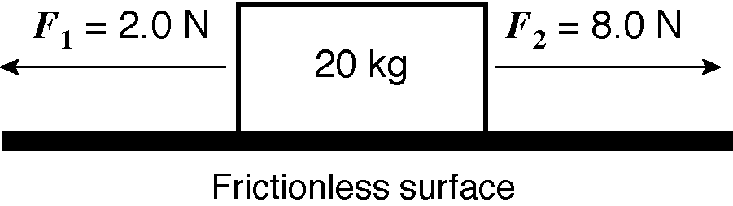

The acceleration of the block is:

A. | 3.0 m/s² to the right.

8. Roger Federer, Swiss tennis star, hits a 60-gram tennis ball with a force of 3 newtons. The ball accelerates at a rate of:
A. | 50 m/s²

9. What is the momentum of a 0.15-kilogram baseball moving at 20 m/s?
A. | 1.5 kg·m/s

10. A boy and the skateboard on which he is standing have a combined mass of 60 kilograms. He throws a 1-kilogram rock forward at 20 m/s. At what speed will the boy roll backward?
A. | 1200 m/s

11. What is the momentum of a 2000-kg car traveling at 20 m/s?
A. | 40,000 kg·m/sec

12. A 10,000-kg rocket is traveling from its launch pad at a speed of 100 m/s. At what speed would 1000 kg of gases be expelled from the rocket?
A. | 1000 m/s

13. A 2-kg piece of clay moving at 4 m/s strikes and sticks to a second 4-kg piece of clay moving at 1 m/s in the opposite direction. What is the speed of the combined piece of clay?
ANSWER: 2m/s
